SURVEY OF INDIA
MAHARASHTRA AND GOA GEO-SPATIAL DATA CENTRE,
(HYDERABAD WING), HYDERABAD –500039.



TENDER FOR
COMPREHENSIVE A.MC. OF HP
DESIGN JET 500 – PS PLOTTERS -2 Nos.

TENDER NO.S- 430/15- C-6 dated. 23- 05-2014.

TO BE SUBMITTED BY :- 23-06 -2014 (15.00 hrs).

Page-2

SURVEY OF INDIA
DEPARTMENT OF SCIENCE AND TECHNOLOGY GOVT.OF INDIA

TENDER DOCUMENT FOR COMPREHENSIVE A.M.C. OF HP DESIGNJET 500-PS PLOTTERS OF SURVEY OF INDIA.

In-charge, Maharashtra & Goa Geo-Spatial Data Centre (Hyderabad Wing), Survey of India, Uppal, Hyderabad –500039. invites Sealed tenders on prescribed proforma for Comprehensive Annual Maintenance Contract (CAMC) of HP Designjet 500-PS Plotters for Survey of India, Hyderabad as per details furnished below. The rates for CAMC should be mentioned clearly indicating the cost and taxes applicable.

4.0. PARTRICULARS OF THE TENDER
(a) Designation and address of the authority : The Incharge, Maharashtra &
inviting tender. Goa Geo-spatial Data Centre
(Hyd.Wing) , Survey of India,
Uppal, Hyderabad- 500039.(AP)

(b) ON-SITE ADDRESS: : As mentioned above.

(c) Tender No. : S- 430 /15-C-6 dt. 23-05-2014.

-----------------------------------------------------------------------------------------------------
Sl.No. Description CAMC Period
-----------------------------------------------------------------------------------------------------
01. On-site Comprehensive AMC For 1 year from the date of
of HP Designjet 500-PS Plotters- 2 Nos. signing of agreement.

Plotter Sl.No.SG 5259203 Z
Plotter Sl.No. SG 4CG8200 J

Date of purchase : Feb. 2005.
----------------------------------------------------------------------------------------------------
(e) Last date and time of receiving of tenders : 23-06-2014 (15.00 hrs)

(f) Date and time for opening of tenders : 23-06-2014 (16.00 hrs)

(g) Total Number of pages of tender document : 05.

Page-3

5.0. OTHER TERMS AND CONDITIONS

(i) The tender should be submitted as per enclosed Annexure `A’ in a sealed envelope duly marked as ‘Tender for CAMC of Plotters” / Tender No.S- 430 /15-C-6 due on 23-06-2014. (15.00 hrs)

(ii) Tender duly signed by tenderer must be addressed to Incharge, Maharashtra & Goa Geo-Spatial Data center (Hyderabad Wing), Hyderabad and not to any individual by name and should be dropped in tender box situated at O/O the Incharge, Maharashtra & Goa Geo-Spatial Data center (Hyderabad Wing), Uppal, Hyderabad –500039. (AP) by 15.00 hrs on or before 12-06-2014. Each page of the tender must be signed by the tenderer.

(iii) Incharge, Maharashtra & Goa Geo-Spatial Data center (Hyderabad Wing), Hyderabad shall not be responsible for any postal delay for non-receipt of tender by due date and time for whatsoever the reason.

(iv) The tenderer should inspect the plotter at the address mentioned above before submitting Quotation and any variation/addition to the quoted amount will not be accepted. The tenderer must ensure that the availability of spare parts before he quotes the rates for CAMC.

(v) The tender quotation should be valid for 90 days from the date of opening.

(vi) The tenderer should furnish a certificate that all the terms and conditions of the tender document are understood by the tenderer and ready to abide by the same without any variation.

(vii) Earnest Money Deposit of Rs.3,000/- should be submitted in the name of In-charge, M&G GDC(HW), Hyderabad through A/C payee Demand Draft or Bankers Cheque, along with the quotation.

(viii) The successful tenderer has to execute an agreement at his own cost and also to submit a security deposit of 20% of the approved quotation rate through Bank guarantee.

(ix) Incharge, Maharashtra & Goa Geo-Spatial Data center (Hyderabad Wing), Hyderabad reserves the right to reject any or all tender(s) without assigning any reason(s).

(x) The tender document can also be down loaded by the intending tenderers from Survey of India web site www.surveyof india.gov.in.

(xi) Latest income tax clearance (Photocopy) is to be submitted along with tender.

(xii) The tenderer should submit the details of PAN in case of proprietorship, TAN in case of partnership and STC(Service Tax Code – a 15 digit number obtained from Central Excise Department) being a service provider.

(xiii) Payment of CAMC will be made in two equal installments for 6 months each.

(xiv) Period of CAMC will be for one year from the date of signing of the agreement.
(xv) All breakdown complaints must be attended to within 48 hours on receipt of cal.
(xvi) Majority of faults should be rectified in the first response itself. However, maximum period allowed for defect rectification shall be 72 hours. If the plotter is not put back in working condition within 72 hours after break-down/fault. SOI shall be free to get the equipment rectified from the market and costs for the same shall be recovered from the maintenance charges to be made to X X X by SOI.

(xvii) The service providing company shall have their office or branch in Hyderabad with qualified personnel for rendering services. If the service providing company does not have office or branch in Hyderabad for rendering services, their tender will be rejected.

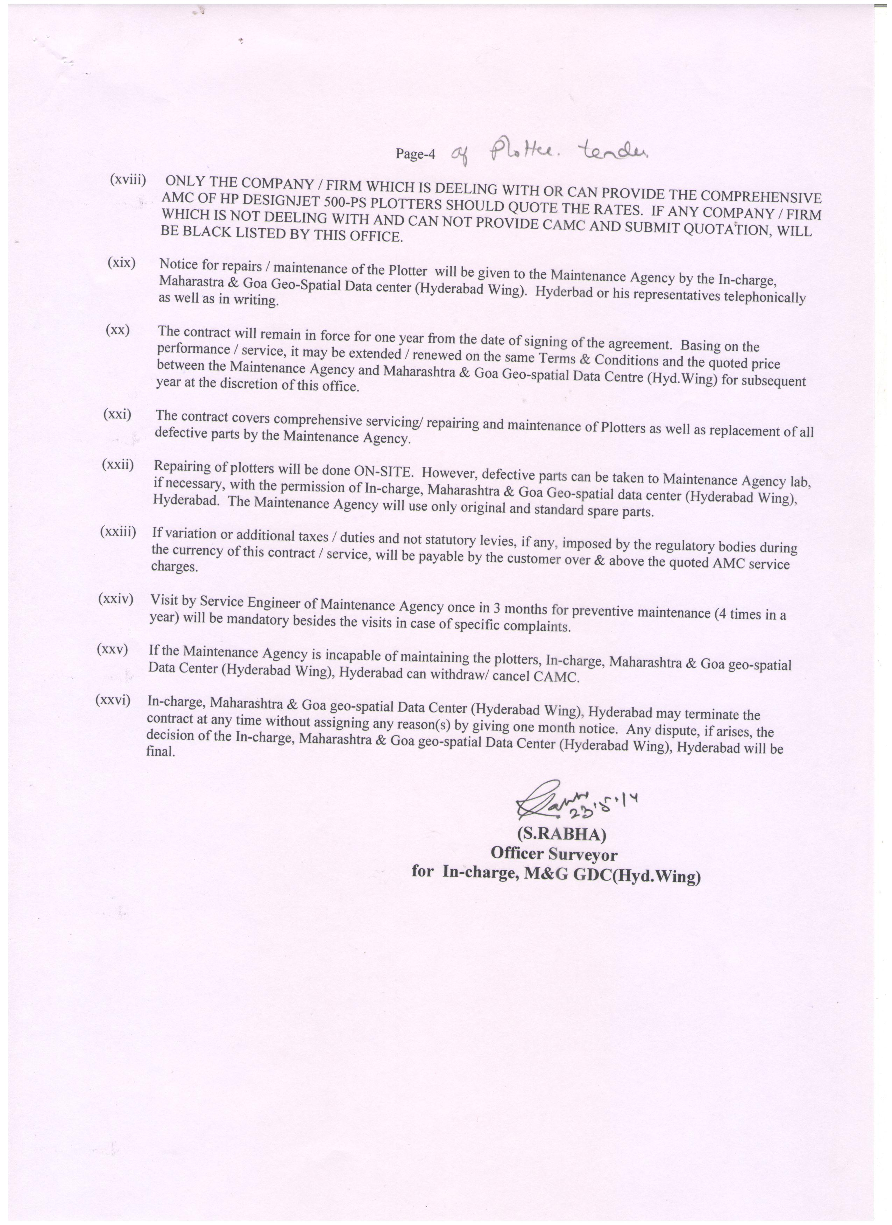

Page-5
ANNEXURE`A’

COMPREHENSIVE ANNUAL MAINTENANCE CONTRACT FOR HP DESIGNJET 500-PS PLOTTERS – 2 Nos.

Rates for Comprehensive Annual Maintenance Contract for HP Designjet 500 – PS Plotters – 2 Nos are given below separately.

Sl.No. | Comprehensive AMC charges | Quantity | Taxes (sales tax/Service tax/ VAT as applicable) | Total (2+4)
1 | 2 | 3 | 4 | 5
01. |  | 1 No.
02. |  | 1 No.

It is certified that all the terms and conditions of tender document
No.S- 430/15-C-6, dt.23 - 05-2014 have been understood by me/us and ready to
accept the same without any variation.

(Signature of Tenderer with Seal)

Station: Name:-

Full Address:-

Phone/E-Mail/Mobile:
Date: Capacity:-

