

TENDER
FOR

PROCURING THE SERVICES OF
MALI
SURVEY OF INDIA,
MINISTRY OF SCIENCE AND TECHNOLOGY
GOVERNMENT OF INDIA

Tender No. 324/11-A-G Dated: 30.05.2014

TO BE SUBMITTED BY : 18.06.2014 (17:00 hours)

Office of the Director,
Kerala & Lakshadweep Geo-Spatial Data Centre
Survey of India
CGO Complex, Poonkulam, Vellayani P.O.
Thiruvananthapuram-695522

SURVEY OF INDIA
(MINISTRY OF SCIENCE AND TECHNOLOGY)
OFFICE OF THE DIRECTOR,
KERALA& LAKSHADWEEP GEO SPATIAL DATA CENTRE,
SURVEY OF INDIA
CGO COMPLEX, POONKULAM, VELLAYANI P.O.,
THIRUVANANTHAPURAM-695522

“NOTICE INVITING TENDER”

Sealed quotations are invited for procuring the services of MALI in Kerala & Lakshadweep Geo-Spatial Data Centre, Survey of India, CGO Complex, Poonkulam, Vellayani P.O., Thiruvananthapuram- 695522 as per the details below:-

- Tender Document can be downloaded from the website www.surveyofindia.gov.in

2. Bid Reference Tender No. 324/11-A-G Dated: 30.05.2014

3. Particulars of Tender
a. Designation of the Authority : Director , K&L GDC,
Inviting Quotations Survey of India, Trivandrum.

b. Last date and time of receipt : 18.06.2014 (17:00 hours)
of sealed Quotation

c. Date & time of opening quotations : 19.06.2014 (15:00 hours)

4. Scope of Work

The Mali shall be employed for cleaning of rooms, corridors, toilets of office buildings and premises of Kerala & Lakshadweep Geo-Spatial Data Centre, Survey of India Office at CGO Complex, Poonkulam, Vellayani P.O., Thiruvananthapuram - 695522. The Mali shall have to work in Day time - during 09:00 hour to 17:30 hours every day except Saturday, Sunday & Closed holidays.

5. Period of Contract and Number of Personnel

- No. of Mali required – 01 (One), Period of Contract – 12 (Twelve) month.

NB :- The above noted number of Mali and the period of hire may vary.

6. ELIGIBILITY AND QUALIFICATION CRITERIA FOR THE PERSONNEL OFFERED ON
SERVICES.

- For the Mali

Educational Qualification: - Literate

- For the Bidder

The bidder must have registration with Labour Office / Register, Company affairs, P.F. Account, E.S.I facilities and Insurance coverage with a valid TAN number.

7. WORK TIMINGS:

Mali shall have to work in the office of Survey of India, Thiruvananthapuram for 08 hrs per day (Excluding ½ an hour lunch break) 05 days week.

8. INSTRUCTIONS TO BIDDERS

Tender (Annexure A and Annexure B ) duly filled in and signed by the tenderer must be addressed to “The Director, K&L GDC, Survey of India, CGO Complex, Poonkulam, Vellayani P.O., Thiruvananthapuram - 695522, and not to any individual by name if sent by post or should be dropped in the Tender Box kept in the Kerala GDC, Survey of India, if submitted by hand, latest by 1700 (hrs) on 18.06.2014.

- Each page of the tender must be signed by the tenderer. The Sealed cover containing Tender should be superscripted “Tender for Mali to be opened only by the Chairman, Procurement Board, Survey of India, Thiruvananthapuram”. Covers not so superscripted are liable to be ignored. Sealed Covers sent by post should have similar superscription.

- It is the responsibility of the bidders to see that their tenders reach the Chairman, Procurement Board at the above address by due date and time. The fact of having posted an offer in time will not bind the Chairman for considering the tender, in case such an offer is delayed in post or misdirected due to incomplete or incorrect superscription or address or any other reason.

- The Chairman, Procurement Board, K&L GDC, Survey of India, shall not be responsible for any postal delay or non-receipt of tender by due date and time due to any reason whatsoever may be.

d) If the due date of receipt/opening of Tenders falls on Holidays the tenders shall be received/opened on the next working day at the same time as specified above. An authorized representative of the Bidder/Firm may remain present during the opening of the tenders.

e) The rates quoted should be on per man-month basis. The rates offered should be valid for acceptance up to 120 days from the date of opening of the tender. Any offer falling short of the validity period is liable for rejection.

f) The rates offered should be firm and final and should be inclusive of Services Tax/taxes as applicable. Service Tax, EPF, Employers Contribution Fund, Employers Contribution on ESIC should be indicated separately. Each item of the Total rates quoted viz minimum Wages.EDL/EPF/PF/ESI/ESIC Administration or Departmental Charges/Inspection Charges/Service Tax should be as far as possible mentioned clearly with percentage (wherever applicable for such taxes/ charges). However the Board shall consider only the total amount for the purpose of acceptance of tender.

g) Completeness of Tender offer: The bidder is expected to examine all instructions forms, terms and conditions in the Tender Documents. Failure to furnish all information required by the tender documents may result in rejection of tender offer. Tender should be neatly filled in and the person signing the tender should, duly authenticate any errors or corrections in the tender.

h) The family members or close relatives of serving Survey of India employee shall not be offered as the service.

9. Evaluation of Bids:

a) The Purchaser will examine the bids to determine whether:

(i) They are complete
(ii) Required EMDs etc have been furnished,
(iii) The documents have been properly signed.

b) Evaluation of bids shall be done based on the information furnished by the bidder. The conformity of the bids to the technical specifications and commercial terms and conditions shall be examined. Responsiveness of the bid shall be determined based on the technical and financial capability of the bidder to execute the contract.

c) The Purchaser will examine the bids to determine the correctness of the information furnished by the bidder in its bid. In case any information is found to be incorrect/false, the bid shall be considered as non-responsive.

d) Purchaser may contact and verify bidder's information, references and data submitted in the bid without further reference to bidders.

e) Purchaser reserves the right to use and interpret the bids as it may, in its discretion, consider appropriate, when selecting bidders for granting of the Letter of Intent/ Notification of Award of Contract,

f) The purchaser may seek clarification in writing from bidder by fax. Bidder shall be promptly reply by fax within the time limit specified in the clarification letter from the purchaser,

g) The comparison shall be of total price of the goods offered inclusive of all taxes.

h) Earnest Money Deposit (EMD)

Bidders are required to furnish i.e. Bid Money /EMD along with the Tender offer. The EMD should in the form of a Account Payee Demand Draft/Bank Guarantee, from a Nationalized bank for Rs. 7000/- (Rupees Seven Thousand only) drawn in favour of “CDDO, K&L GDC, Survey of India” payable at Thiruvananthapuram, valid for 60 days from the date of opening of the tenders. Unsuccessful Bidders money shall be refunded within 30 days after the expiry of the period of the tender offer validity prescribed by the Survey of India, EMD will be refunded to the successful bidder after signing of the Contract Agreement on the terms and conditions as stipulated in this Tender Document and after obtaining Performance Security from him. No interest will be paid for the Bid Security Amount.

If the successful tenderer fails to furnish the Performance Security, the whole Earnest Money Deposit shall be forfeited without any reference to the successful tenderer.

- All bidders should enclose photocopies of the following documents along with the Tender Offer.

- Valid Registration Certificate & License from the Labour Commissioner.
- Provident Fund A/C No.
- PAN/TAN
- Service Tax Registration Certificate
- Certificate/Proof showing that the Service Tax has been paid up to March 2014.
- Documents indicating date of establishment of firm, Name of the Head (s) of the firm and their
contact details viz. Fax, E-mail ID.
- The list of firms/organizations to which Security Guards, Office Boys and Mali have been provided during the last one year.
j) The Chairman, Procurement Board K&L GDC, Survey of India, CGO Complex, Poonkulam, Vellayani P.O., Thiruvananthapuram - 695522 reserves the right to reject any or all tenders without assigning any reason. The Chairman does not bind himself to accept the lowest tender.

k) LAST DATE & TIME OF RECIEPT OF SEALED QUOTATIONS IS 08.04.2014, (17:00 Hrs). Quotations received after due date and time, as stipulated herein, shall be summarily rejected.

10. TERMS AND CONDITIONS OF THE CONTRACT

- Performance Security

The Performance Security should be furnished for an amount of 10% of the Contract Value valid for a period of 60 days beyond the date of completion of all contractual obligations. The successful contractor shall furnish the performance security in the form of either an Account Payee Demand Draft in favour of “ CDDO, K&L GDC, Survey of India” payable at Thiruvananthapuram or a Bank Guarantee, protecting the interests of the Government in all respects, The proceeds of the Performance Security shall be payable to the Survey of India as compensation for any loss/penalties/liquidated damages resulting from the service provider’s failure to honour its obligations under the contract.

The performance security shall be returned to the Contractor on successful completion of the services for which the Mali were hired.

- Good Conduct of the Personnel

- The agency should provide the service of trained Mali and will furnish a Certificate that the Mali are trained and none of the Mali were discharged from the service on ground of criminal charges, theft and unreliability.

- The service provider shall ensure that the behavior of the Mali deployed by them is decent. The service provider shall be fully responsible for misconduct and indecent behavior by the Mali so deployed. Such personnel, whose conduct is reported against, shall have to be immediately replaced.

- The service provider shall furnish an affidavit that none of their Mali deputed to work under this contract will later ask for employment under the Government. If the services provided by the contractor are not found satisfactory, the contract can be terminated by Survey of India after giving a month’s notice to the contract.

- Leave etc. to the Mali
- The agency shall deploy the full strength of personnel all the time and shall maintain a list of the reserve to provide the replacement.
- Payment Terms

- Payment to the Service provider for the manpower deployed will be made on monthly basis by the office after deduction of Tax at the rates in force.
- Payment to the Mali should be made in the presence of representative of Survey of India and a copy of acquittance showing the payment to each Mali should be furnished to our office.
- In no case any payment shall be made by our office directly to the Mali so hired, for broken periods of employment, the payment will be made on prorate basis. The Contractor shall not press a claim for any pecuniary compensation in case the payment for any particular month is delayed as a result of Administrative & Financial reasons.

- RESOLUTION OF DISPUTES

- Any dispute shall be first sorted out by the Director, Kerala GDC. If the dispute persists and remains unresolved, it will be entertained by the Surveyor General of India, or his representative, whose decision shall be binding on both the parties.

- This tender is meant only to finalise the rates for procuring the services of Mali in SOI offices located at Thiruvananthapuram. The successful tenderer will have to enter into further Agreement with the Director, Kerala GDC on the Terms & Conditions listed in this Tender Document.

- The Board shall consider only the consolidated rate quoted by the bidders without going into the itemwise details of the total consolidated rates. Thus the firm/bidders shall themselves be responsible to ensure compliance with the Minimum Wages Act/Rules and statutory provisions of the Labour Act. The rates should be firm & final. No request for increase in rates due to any reason whatsoever shall be entertained by the Government during the period of hire.

- If any firm/fails to provide the services of Mali at the accepted rates on the scheduled date & time, the contract awarded shall be cancelled & Performance security shall be forefeited. The contract shall thus be awarded to such firm whose rates are found next subject to other conditions stipulated in the tender document.

- Compliance with Labour Regulations

During continuance of the contract, the Contractor shall abide at all times by all existing labour enactments and rules made there under, regulations, notifications and bye laws of the State or Central Government or local authority and any other labour law (including rules), regulations, bye laws that may be passed or notification that may be issued under any labour law in future either by the State or the Central Government or the local authority. The Contractor shall keep the Employer indemnified in case any action is taken against the Employer by the competent authority on account of contravention of any of provisions of any Act of rules made there under, regulations or notifications including amendments. If the Employer is caused to pay or reimburse, such amounts as may be necessary to cause or observe, or for non observance of the provisions stipulated in the notification/bye laws/Acts /Rules/Regulations including amendments, if any, on the part of the Contractor, the

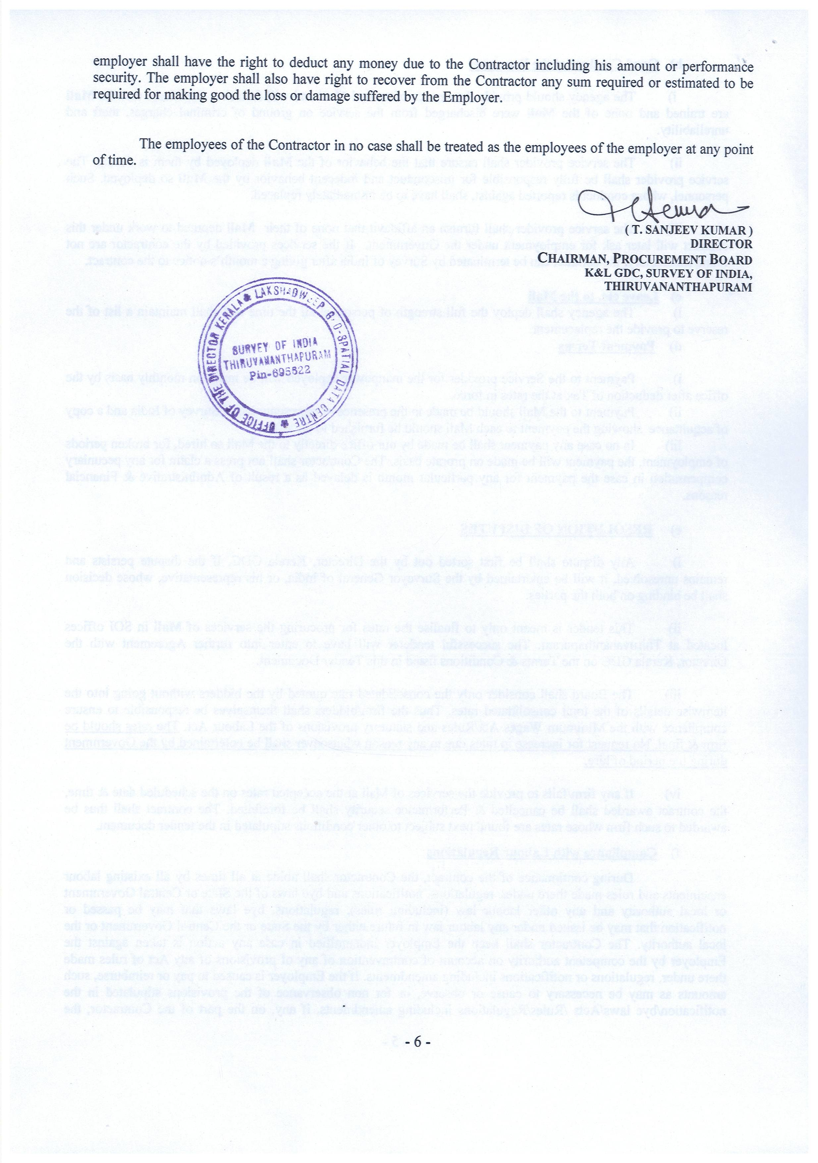

Annexure-A
TENDER OFFER/QUOTATION

To,

The Chairman, Procurement Board,
K&L GDC,Survey of India
CGO Complex,
Poonkulam, Vellayani P.O.,
Thiruvananthapuram-695522

After having examined the tender documents including all Annexures, we offer to supply Mali in accordance with the said tender document.

We undertake, if our tender offer is accepted, to commence the services within_________(number) days calculated from the date of signing of the Contract Agreement.

If our tender offer is accepted we will submit a bank guarantee for a sum of 10% of the Contract Value for the due performance of the Contract.

We hereby agree to abide by this Tender offer for 120 days and the same shall remain binding upon us and may be accepted at any time before the expiry of that period.

We are aware that you are not bound to accept the lowest or any offer you may receive.

Dated this ______day of __________________ 2014.

Signature:___________________________________

( ___________________________ )
Duly authorized to sign the tender offer for and on behalf of

Annexure-B

BID FORM

(The Firm may furnish the requisite information on their own proforma also)
(To be enclosed with the Quotation)

Unit Prices/Rates (to remain valid for a period of two years from the date of singing of the contract.

Description of Manpower/services | Break details of the Rate (Minimum Wages, PF, ESIC, Service Tax, Adm/Service Charges etc) | Unit Consolidated Rate (per man month)  (in Rs.)
Mali  (on Contract basis) | 1
Mali  (on Contract basis) | 2
Mali  (on Contract basis) | 3
Mali  (on Contract basis) | 4
Mali  (on Contract basis) | 5
Mali  (on Contract basis) | 6
Mali  (on Contract basis) | 7
Mali  (on Contract basis) | Total:

Rate for one Mali
Rate (in figures) Rs. __________________

Rate (in words) Rupees__________________________________

Signature of Contractor ________________________

Postal Address:_________________________________________________________________

Place:
Date:

Annexure-C

Contract Agreement
(Agreement to be executed on a Non-judicial Court Stamp of Rs. 100/- value)

AGGREMENT MADE on this____________ day of _______________________________Two thousand fourteen between_________________________________________________ (hereinafter called “the Service Provider or Contractor”) on one part and the Director, Kerala & Lakshadweep Geo Spatial Data Centre (hereinafter referred to as the “Government”) on the other part.

WHEREAS the Service Provider has tendered to the Chairman, Procurement Board for providing Mali as per the instruction given at the prices or rates mentioned in the Bid Form and whereas such tender has been accepted and the contractor has deposited with the Government the sum of Rs. ________(Rupees______________________________________
only) as performance Security for the fulfillment of this Agreement.

Now it is hereby agreed between the two parties as follows:

1. The contractor has accepted the contract on the terms and conditions listed in the Tender Document of the Tender Notice No. ______________ which will hold good during the period of this agreement.

2. Upon breach by the contractor of any of the conditions mentioned anywhere in the Tender Document, the Government may issue a notice in writing, and put an end to this agreement without prejudice to the right of the Government to claim damages for antecedent breaches thereof on the part of the Service Provider and also to reasonable compensation for the loss caused by the failure of the contractor to fulfill the agreement as certified in writing by the Government whose certificate shall be the conclusive evidence of the amount of such compensation payable by the contractor to the Government.

3. The Service Provider has deposited with the Government a performance Security Deposit of Rs _____________ as security for compliance and performance in accordance with the Contract. Upon the completion of the contract, the Performance Security Deposit shall after the expiry of ___________ months from the date if signing this agreement will be returned to the Service Provider, without interest, and after deducting any sum due by the Service Provider to the Government under the terms and conditions of this agreement.

4. This agreement shall remain in force until 3 months after the expiry of the contract period.

5. Not with standing anything contained herein the tender and acceptance forms contained, the Government shall not be bound to take the whole or any part of the estimated manpower mentioned herein and may cancel the contract at any time upon giving one month’s notice in writing without compensating the Service Provider in anyway whatsoever.

6. In consideration of the payments to be made by the Government to the Service Provider as mentioned in the Tender Document, the Service Provider hereby agree to provide to the Government the Mali and to remedy shortcomings/deficiencies therein, if any, in conformity with the terms and Conditions of the Contract.

7. In witness thereof the service provider ____________ has set his hereto and Director, Kerala & Lakshadweep Geo Spatial Data Centre or his authorized representative has on behalf of the Government of India affixed his signature and sea thereto on the day and the year noted above.

Contractor: Survey of India:

Witness:________________________ Witness _______________________

Place : Thiruvananthapuram

Annexure D
PERFORMANCE SECURITY FORM

To,
The CDDO,
K&L GDC, Survey of India
CGO Complex,
Poonkulam, Vellayani P.O.,
Thiruvananthapuram.

WHEREAS _____________________________________________________(Name of Service Provider hereinafter called “the Service Provider” has undertaken Contract No. ___________________ _ dated__.04. 2014 to supply _________________Description of Services) hereinafter called the Contract. AND WHEREAS it has been stipulated by the Government in the said Contract that the Service Provider shall furnish to you a bank Guarantee by a recognized bank for the sum specified therein as security for compliance with the Service Provider’s performance obligations in accordance with the Contract.

AND WHEREAS we have agreed to give the Service Provider a guarantee:

THEREFORE WE hereby affirm that we are Guarantors and responsible to you, on behalf of the Service Provider, up to a total of _____________________________________(Amount of the Guarantee in Words and Figures) and we undertake to pay you, upon the Government’s written demand declaring the Service Provider to be in default under the contract and without cavil or argument, any sum or sums within the limit of ____________________________ as aforesaid, without your requiring to prove or to show reasons for your demand or the sum specified therein.

This guarantee is valid until the _____________day of ___________________2015

Signature and Seal of Guarantors

____________________________________
____________________________________
____________________________________

Date:________________________________

Address:_____________________________

