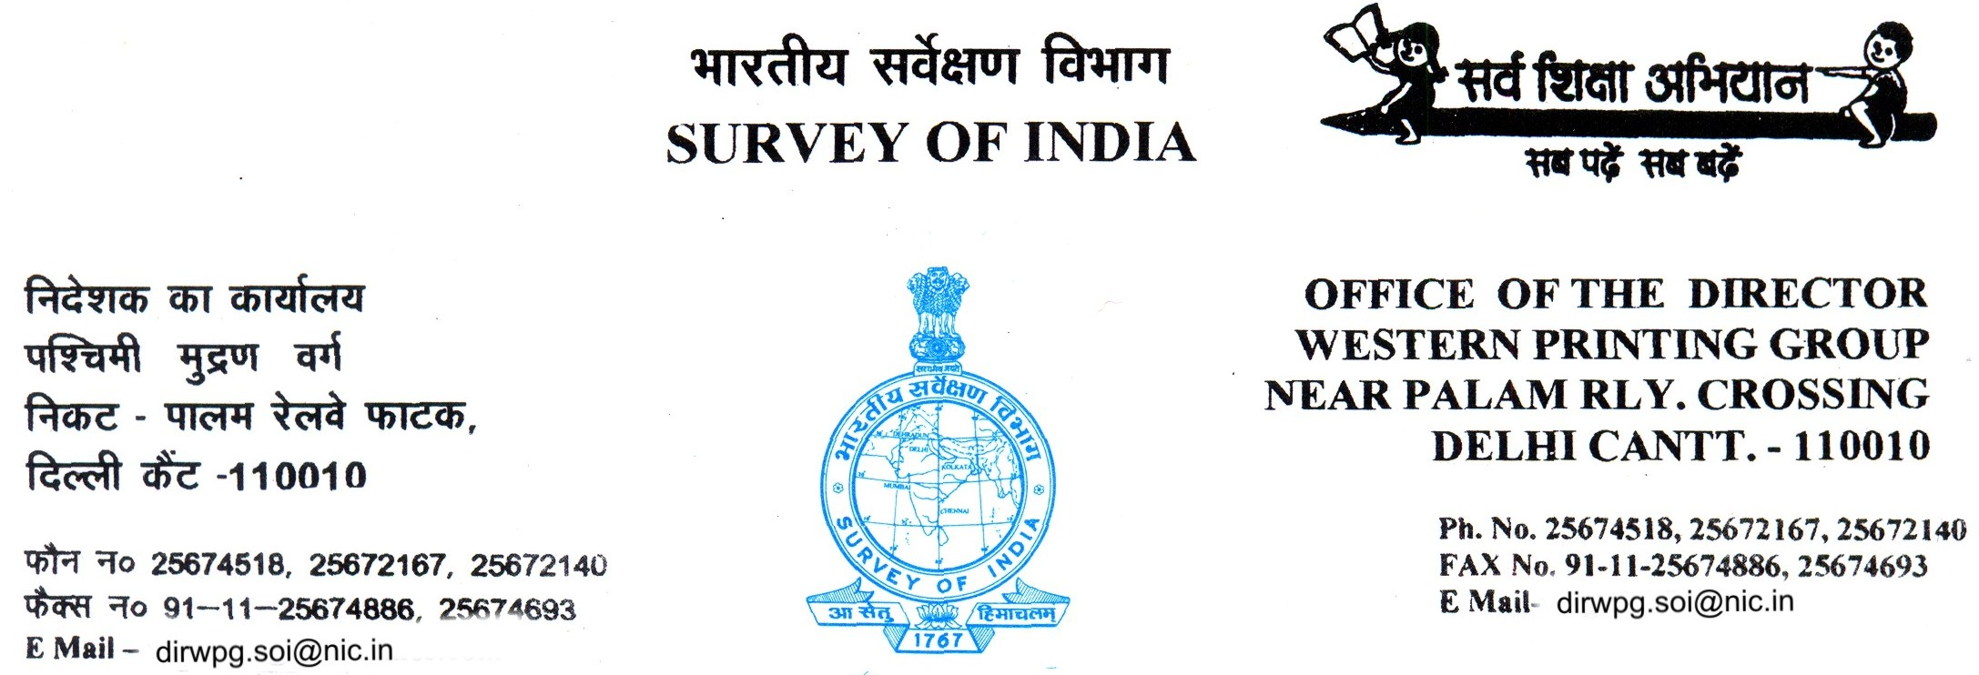

No.WPG / 867/15-AS (Rep.) Tender Dated: 10/10/2014

To
M/s _______________________________
_______________________________
_______________________________

SUB: INVITATION OF QUOTATION FOR FLIP BOOK BINDING WORKS etc.

Dear Sirs,

We are interested to get book binding work etc. as per the details in the enclosed tender. Please submitt your quotation with terms & conditions for supply of services in a sealed cover super scribed with “Tender for FLIP Book Binding Work etc”.

Your quotations should reach this office on or before 28/10/2014.

Quotations received late will not be considered.

Director, Western Printing Group reserves the right to reject any or all offers received or accept any offer in whole or in part, without assigning any reason.

The rates offered should be valid for One year.

Yours Sincerely

( S. GHOSH)
Manager (Jr.)
For Director
Encl:- As above ( Tender Form )

WESTERN PRINTING GROUP
SURVEY OF INDIA

PALAM VILLAGE ROAD
NEAR RAILWAY CROSSING
DELHI CANTT-10

LIMITED TENDER DOCUMENT

FOR

INVITING TENDERS FOR
BOOK BINDING WORK

TO BE SUBMITTED BY - 28.10.2014 (1400 Hrs.)

TO BE OPENED ON - 28.10.2014 (1530 Hrs.)

2

WESTERN PRINTING GROUP
SURVEY OF INDIA
PALAM VILLAGE ROAD
NEAR RAILWAY CROSSING
DELHI CANTT. – 10
Tele Fax: 011-25674693
E Mail: wpf.del.soi@gov.in

1. Item - BINDING WORK.(A4 Size Book)
2. Designation and address of the DIRECTOR, WESTERN PRINTIN GROUP
officer to whom the tender is to Palam Village Road, Near Railway Crossing,
be submitted Delhi Cantt. – 10.

3. Consignee - As above

4. Last date & time of receiving the tenders - 28.10.2014 (1400 hrs.)

5. Date & time of opening of tenders - 28.10.2014 (1530 hrs.)

6. Detailed description of the item - Please see Annexure ‘A’ (Enclosed)

7. GENERAL:

- The tenders should be submitted in sealed cover marked “Tender for FLIP Book Binding work.” along with terms & conditions. The tender is to be submitted with complete information / document etc. to avoid unwanted correspondence after opening the quotations.

- Tenderers must have in house facilities for, Lamination, Thermal Coating, Section Sewing Binding, Die cutting/ Indexing, Numbering including delivery at the site.

- Tenderers must note that the tender once submitted will not be altered for whatsoever reasons and should not have any scope of ambiguity, cutting or overwriting.

- Tenderers should have annual Turnover At least 5 Lakhs per annuam.

- Tenderers should enclose last year ITR along with annual Turnover statement, self attested copy of valid Sales Tax / VAT return and PAN card.

3

8. RATES:

Price quoted in the given format and including all. i e packing, forwarding, collecting and delivery charges etc. to the consignee’s site. It should also be inclusive of all taxes and octrio charges, if any.

9. VALIDITY OF THE TENDER:

The tender should remain valid for a period of at least One year from the date of opening.

10. OPENING OF TENDER:

The authorized representative with proper authority letter from the Firms will only be allowed to attend the Tender Opening on 28.10.2014 (1500 hrs.) in the office of Director, Western Printing Group, Delhi Cantt. 10.

11. INSPECTION:

The final inspection of the books/works/goods is to be done at consignee’s site i.e. by the Director, Western Printing Group, Delhi Cantt. – 10. or his authorised representative against the approved specifications.

12. DELIVERY:

The supply of books/works/goods will be made at consignee’s site or to the site specified by the indenter within 15 days or the time as Directed by the competent authority from the date of issue of supply order, failing which the order may be cancelled without being prejudice to the expenditure incurred by the firm. All the waste/extra printed sheets will have to be returned back Positively to the indenter along with the supply.

13. PACKING:

I. The books/works/goods are required to be securely packed to avoid damage in transit and each packet / bundle should have No. of books with books serial numbers/works/goods. Damaged supply, if any, will not be accepted.

II. The supply of the said materials to consignee’s site will be made by the supplier on their risk and cost.

14. PENELTY:

Director has reserve the right to deduct 10% to 25% of cost, during final payment if unable to supply within prescribed time.

4

15. PAYMENT:
Payment will be made within 45 days from the date of final inspection and acceptance of the final supply. TDS will be deducted as per rule. Please give the details of your Bank account as given below for receiving the Bill payment through N.E.F.T.

- Account Holder’s Name:
- Name of the Bank:
- Bank Account Number:
- IFSC Code:
- Branch Name:
- Pan Number:

16. The tender document can also be downloaded from the Survey of India website: www.surveyofindia.gov.in.

17. The Director, Western Printing Group, Survey of India, Delhi Cantt., reserves the right to reject / cancel and accept all or any part of the tender without assigning any reason thereof.

18. IMPORTANT

(a) The books/goods/works may contain classified information and therefore, during the binding of books, representative of this office will supervise the work round the clock for security purposes (for books having classified information). The vendor will also be equally responsible for the security of the printed materials.

(b) Tenderer can be see the specimen book in any working day (Monday to Friday) from 9.30 AM to 5.30 PM.

5

RATES :-

Binding is done at your Premises ( Including To & Fro Charges)

- Section Sewing Binding up to 460 Pages - Rate per book - Rs. …….

( Operation involved in Binding of FLIP Book – Cover Lamination, Creasing of Cover, Numbering at two places, Pasting of Separator at varies places ( 40 appx.) with Zigdex Die cutting.)

Note ;- Sample Book can also be seen in this office at any working days during office
Hours (9.00 -17.30 hours)

6

ANNEXURE‘A’

SPECIFICATION OF BOOK

  - Binding - Section Sewing.

  - Pasting of cover - by Machine

  - Lamination and Creasing - Cover

  - Numbering of book - at two places.

  - Pasting of extra Leave/ Separator – appx. 40

  - Die cutting/ Indexing (Zigdex) of Separator – appx. 40

