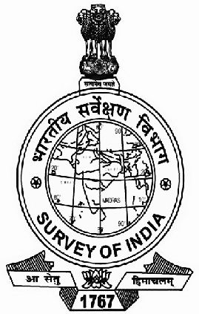

EASTERN ZONE OFFICE
SURVEY OF INDIA
15 WOOD STREET, KOLKATA – 700 016.

PROCUREMENT OF
PROFESSIONAL 3D GRAPHICS CARD
FOR COAL MINE PROJECT SURVEYS (CMPDI)

CORRIGENDUM No. EZO/S-187/ 15-C (PROCUREMENT) DATED 05.02.2013 TO TENDER NO. EZO/S-61/ 15-C(PROCUREMENT) DATED 11.01.2013

SL # | PAGE # | PARA # | CORRIGENDUM
1 | 3 | 6.A (a) | Remove words ”DELL PRECISION T-5500”
2 | 13 | 1 | Delete Column “In Foreign Currency”
3 | 13 | 1(a) | Remove words “as per Proforma Invoice from Foreign manufacturer / Supplier (as per details given in Annexure ‘B’ (i)”
4 | 13 | 1(d) | Replace words “Delhi Air Port” with “Indian Port”

All other contents of original Tender remain unaltered except the above.

CHAIRMAN, PROCUREMENT BOARD
C/O ADDITIONAL SURVEYOR GENERAL
EASTERN ZONE, SURVEY OF INDIA
15 WOOD STREET, KOLKATA-700016

