Urgent

By Fax / By E.Mail / By Speed Post.

SURVEY OF INDIA
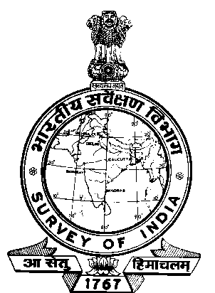

Telefax : (040) 27206159 OFFICE OF INCHARGE
E-mail : mgdcsoihyd@hotmail.com MAHARASHTRA & GOA GDC
(HYDERABAD WING)
CST&MP CAMPUS
SURVEY OF INDIA, Uppal
HYDERABAD – 500 039

No.S- 136 / 15-L-1. Dated the: 07 -02-2013.

To
The Addl.SG,
NGDC
Survey of India
Dehra Dun.

SUB: UPLOADING OF ‘CORRIGENDUM’ TO OUR TENDER NOTICE
IN SOI WEBSITE -REG.

Ref: Our letter No.S-1352/15-L-1 dt.27-12-2012 addressed to Surveyor General of India
with a copy to you alongwith Tender Notice No.1351/15-L-1 dt.27-12-2012 with
Hard copy & Soft copy.

*****

Please arrange to upload the enclosed corrigendum against our Tender Notice
No.S-1351/15-L-1 dt.27-12-2012. Soft copy of the above is sent herewith by Speed Post.

Sd/-
Encl: As above. (D.K.KAR)
Superintending Surveyor
for In-charge, M&G GDC(HW)

Copy to: i) The Surveyor General of India – for information, please.
ii) The Director, M&G GDC, Pune – for information, please.

Store.curr.file.15-L-1/p.45

M&G GDC (Hyderabad Wing)
Survey of India
Uppal, Hyderabad.

CORRIGENDUM TO TENDER NOTICE NO.S-1351/15-L-1 DT.27-12-2012.

The change in date of submission / date of opening of quotation for the above
quoted Tender Notice is given below:

01. The last date and time of submitting tender may be read as 04-03-2013
(16.00 hrs) in place of 18-02-2013 (16.00 hrs).

02. Date and time for opening of quotation may be read as 05-03-2013
(11.00 hrs) in place of 19-02-2013 (11.00 hrs)

Sd/-
(D.K.KAR)
Superintending Surveyor
For In-charge, M&G GDC(HW)

